**Question 1**

Louis and Dewey live in adjacent houses and are part-time private tutors, who give lessons from home. Louis is a maths tutor, and Dewey is a rock-and-roll music tutor. (If you think the latter sounds weird, there is a real-life School of Rock in Philadelphia. Look it up!) Unfortunately, Louis has trouble getting students because they cannot concentrate while Dewey’s students play loud music. Suppose that Dewey earns $10,000 from tutoring, but would earn $0 if he were forced to keep the house quiet. Louis earns $2,000 if it is noisy, but would earn $11,000 if it were quiet.

A. Is it socially efficient for Dewey to be loud or keep quiet?

B. Suppose that there is a law saying that residents are not allowed to make noise that is disturbing to their neighbors. Based on the Coase theorem, will Dewey be loud or keep quiet? Explain.

C. Suppose that there is no law limiting loud noise. How will the outcome be different?

D. Again, suppose there is no law, and also suppose that it is possible for Dewey to soundproof his house for $5,000. How can the socially efficient outcome be achieved?

**Answer:**

A. It is efficient for Dewey to be loud, because his surplus if he can make noise is $10,000, while Louis’s surplus if Dewey is quiet is $9,000.

B. Even though Louis has a legal “right” to quiet, he values this right less than Dewey values being able to make noise. Therefore, Louis could sell his right to Dewey for an amount between $9,000 and $10,000, and both would be better off.

C. If there is no law limiting Dewey’s noise, then Louis would not be willing to “buy” Dewey’s right to make noise because it values it less than Dewey does. Thus, the end result is the same. Dewey will be loud, which is the efficient outcome.

(Note that Louis obviously prefers the case where he has a right to quiet, while Dewey prefers the other case. However, in both cases the outcome is efficient because the action with greater benefits than costs – Dewey making noise – is taken.)

D. In this case, the most efficient outcome if for Dewey to soundproof his house and make noise. Given that Dewey is making noise, soundproofing decreases his surplus by $5,000 but increases Louis’s surplus by $9,000. So, Louis would be willing to pay the cost of the soundproofing, and the efficient outcome will be achieved.

**Question 2**

Education is heavily subsidized (or publicly provided) in most countries. Can you provide an economic argument for why this is a good policy?

**Answer:** There are many positive externalities associated with individuals becoming more educated. For example, in a democracy, an educated population may choose better leaders. Also, in a country with progressive taxation (those with higher incomes pay a higher percentage of their income in taxes) and social programs, those with higher education tend to earn more income and contribute more to government revenues. Individuals with more education are also more likely to develop a new product, process, or technology that will make others more productive, and they tend to be less likely to commit crimes. Keep in mind, though, that most of the benefits of education, such as higher future salary and social connections, are private benefits and not externalities.

Another argument for subsidized education is that it is an effective way to promote a more equal distribution of income because it allows the children of both wealthy and poorer parents to have access to the same career opportunities. This is a positive externality to the extent that individuals value the economic equality of the society they live in.

**Question 3**

Fertilizer runoff from farms can cause ocean “dead zones” near the mouths of rivers. Among other things, the existence of these zones reduces the catch of fishermen in the area. Suppose that corn farms are one source of fertilizer runoff. Using a graph, demonstrate the deadweight loss associated with the competitive market equilibrium for corn.

**Answer:** Because corn production entails a negative externality, the social supply curve (which is equal to the marginal cost of production plus the marginal external cost) is above the private supply curve, and the efficient quantity of corn (Q*) is below the market equilibrium quantity (QM). Thus, the deadweight loss associated with the competitive market equilibrium is equal to the area of the shared, below the social supply curve and above the demand curve for the quantity above the efficient level.

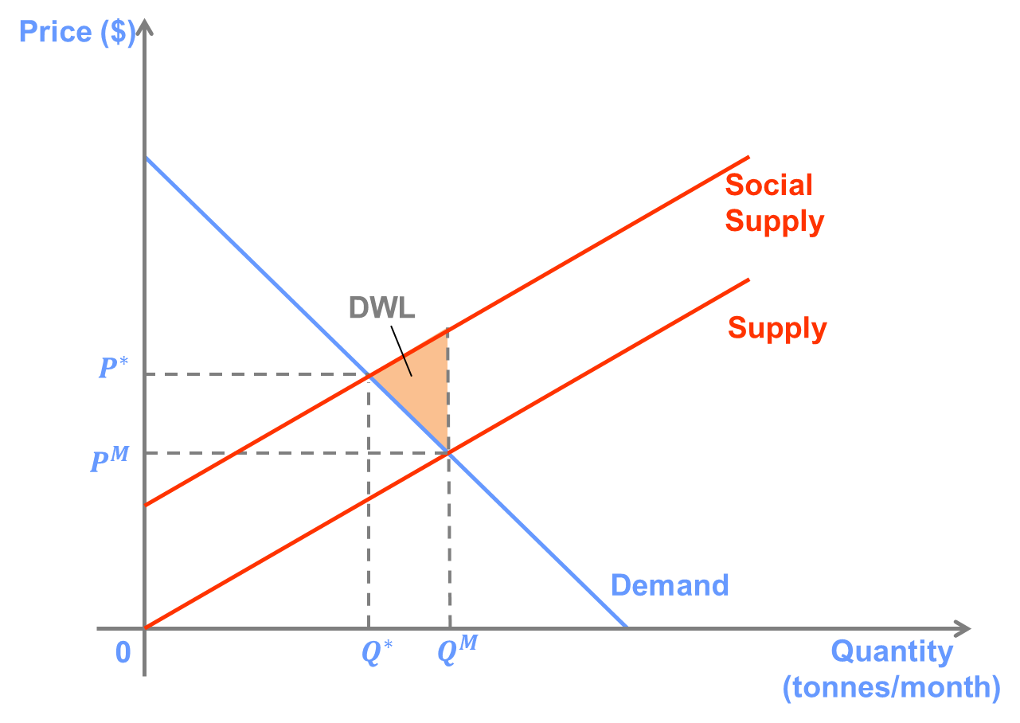

**Question 4**

Explain how cigarette smoking is likely to produce an externality. Is this externality likely to be corrected by private bargaining? Using a graph, discuss the relative merits of a ban on cigarette smoking compared to a tax on cigarettes.

**Answer:** Second-hand smoke from cigarettes has been shown to cause cancer, and many people find the odor unpleasant. This is an external cost, which is not borne by the person choosing to smoke. In addition, if health care is provided by the government or subsidised by insurance schemes, then the costs of the negative health effects on the smoker are also borne to some extent by others.

The externality may be corrected by private bargaining in small groups. For example, a smoker is not likely to smoke in a non-smoker’s house due to social pressure. However, in public places and large venues such as restaurants and stores, it may be difficult for all affected parties to negotiate in order to reach an efficient outcome.

The graph below depicts the market for cigarettes. The social supply curve is drawn above the private supply curve to reflect the external costs of cigarette smoking.

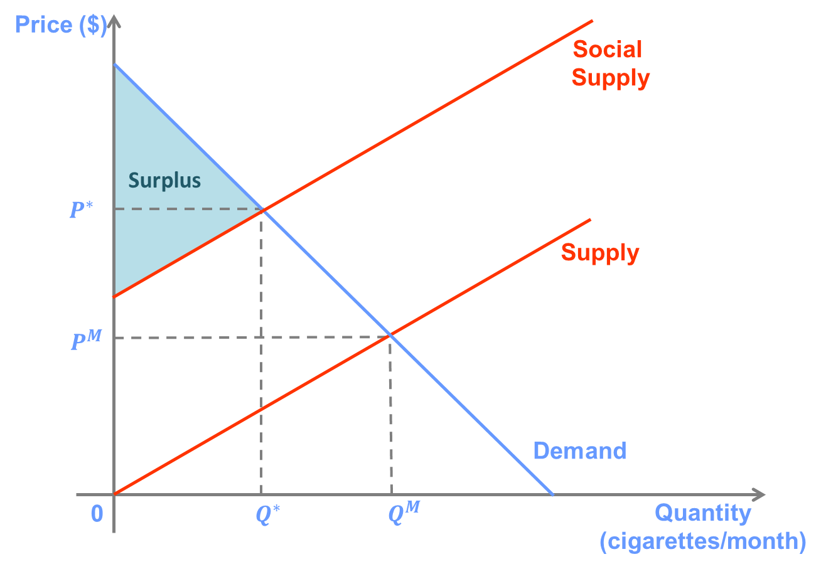

We can see that the optimal quantity (Q*), which maximises total surplus, is less than the market equilibrium quantity (QM). However, it is greater than zero. A tax equal to the marginal external cost of cigarette smoking will lead to the optimal quantity being consumed and total surplus equal to the area of the shaded region. On the other hand, an effective ban will cause quantity to be equal to zero, which results in zero surplus.

So, a tax is more effective at creating an efficient outcome than a total ban on smoking. This is because cigarette smoking has some benefits, the enjoyment people get from smoking. As a result, even though the costs (both to smokers and non-smokers) are very large, some smoking generates surplus for society.

(Note: This is not to say that banning cigarettes in some locations, such as bars and restaurants, is not optimal. In confined spaces, it may be that the costs of even one cigarette being smoked outweigh all the benefits to the smoker.)

**Question 5**

Suppose that in the Sydney suburbs the demand for flowering plants is given by P = 60 – Q, and supply is given by P = 0.2Q, where Q represents thousands of a plants. Because people enjoy seeing flowers as they pass by others’ houses, these plants produce a positive externality. Suppose that each plant produces a marginal external benefit equal to $6.

A. What will be the market price and the quantity supplied of flowering plants?

B. What is the socially optimal number of plants?

C. Calculate the deadweight loss associated with the competitive market outcome.

D. How would you suggest that the government correct the inefficiency caused by this externality?

**Answer:**

1. P=$10, Q=50
2. To find the socially optimal quantity, we have to add the marginal external benefit to the demand curve. (Remember that P must be isolated on the left-hand side so that we are adding the extra benefit to consumers’ reservation price, i.e. adding vertically.) So, MSB = 66 – Q, so the socially optimal quantity is 55,000.
3. To calculate the deadweight loss, it is helpful to draw the graph.

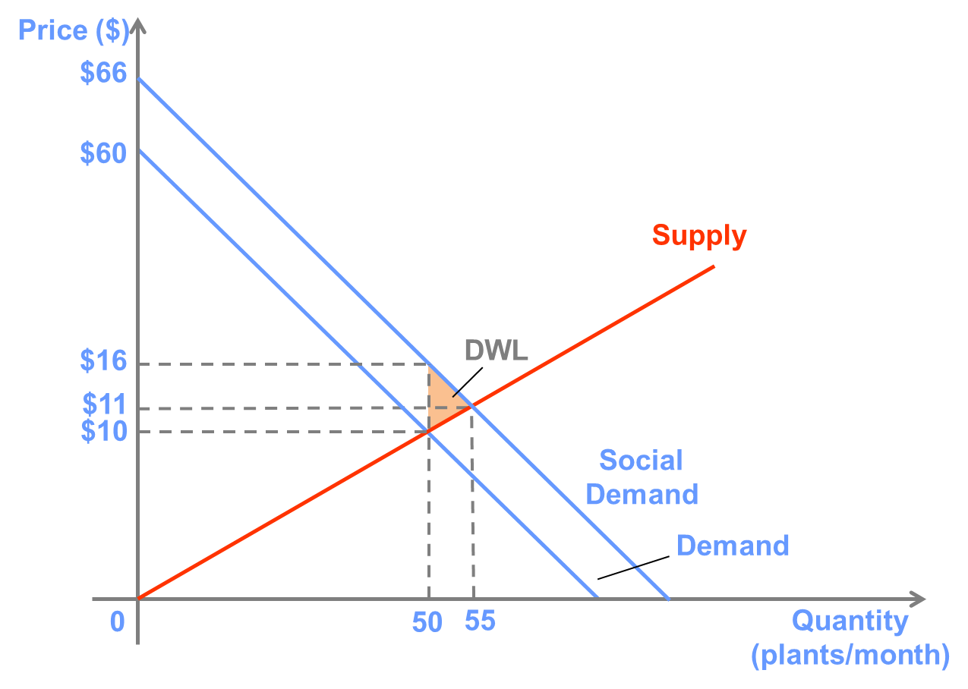

The deadweight loss is equal to the area of the shaded region, which represents lost surplus from not consumer goods for which the marginal social benefit is above the marginal cost.

The deadweight loss is equal to ($16 – $10)x(55,000-50,000)/2 = $15,000

1. The simplest way for the government to correct the inefficiency caused by this externality would be to provide a subsidy for flowering plants equal to $6 per plant. This would increase private demand so that it would coincide with social demand, and the socially optimal quantity will be produced.